**Assignment 2.2**

1. Create a file max-temp.txt in Local File System and move the file to /user/acadgild/Hadoop

Created a file **max-temp.txt** in local file system

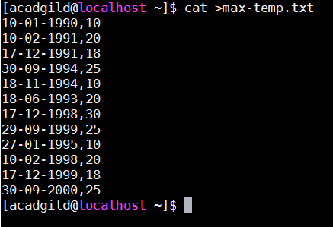

Moved the file **max-temp.txt** from local file system to **/user/acadgild/Hadoop** using the command

**-copyFromLocal**

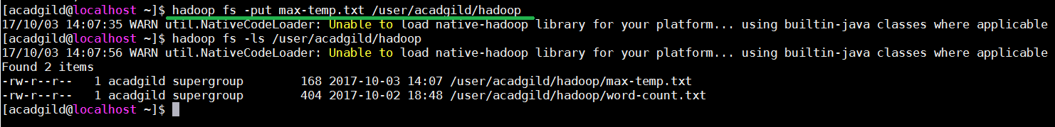

1. Creating owner and group for the file max-temp.txt

We can use the command **–chown OWNER:GROUPNAME <src file>**.

Usage: **Hadoop fs –chown Amit:Batch1 /user/acadgild/Hadoop/max-temp.txt**

Here, Amit is the owner and Batch1 is the group

